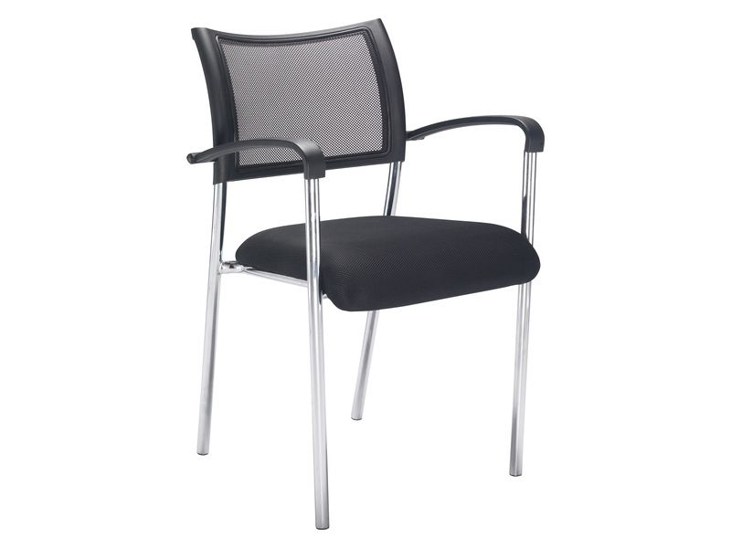

|  |  |
| --- | --- |
| Height (mm) | 860 |
| Width (mm) | 555 |
| Length (mm) | 550 |
| Weight (kg) | 5 |
| Colour | Black |
| Commodity Code | 9401710000 |
| Recommended Usage Hours | 8 |
| Seat Height - Static (mm) | 485 |
| Delivery Time | 2-3 working days |
| Warranty | 2 year parts / |